Annual Processing Procedures
All areas of the Annual Processing Procedures should be accessed via Tax Reporter through transaction PU19.

Tax Reporter Log Manager

Access the Tax Reporter Log Manager

- Enter your agency’s Tax Company (use drop down to see all options)
- Enter Reporting Period End Date – i.e. 12/31/CCYY (ex: 2015)
- Enter Consider Payroll Results up to – i.e. 12/31/CCYY (ex: 2015)
- Select the arrow in front of Annual on the left side of the screen
- Select W-2 Wage and Tax Statement
- Select Log Manager button above the Tax Forms area.
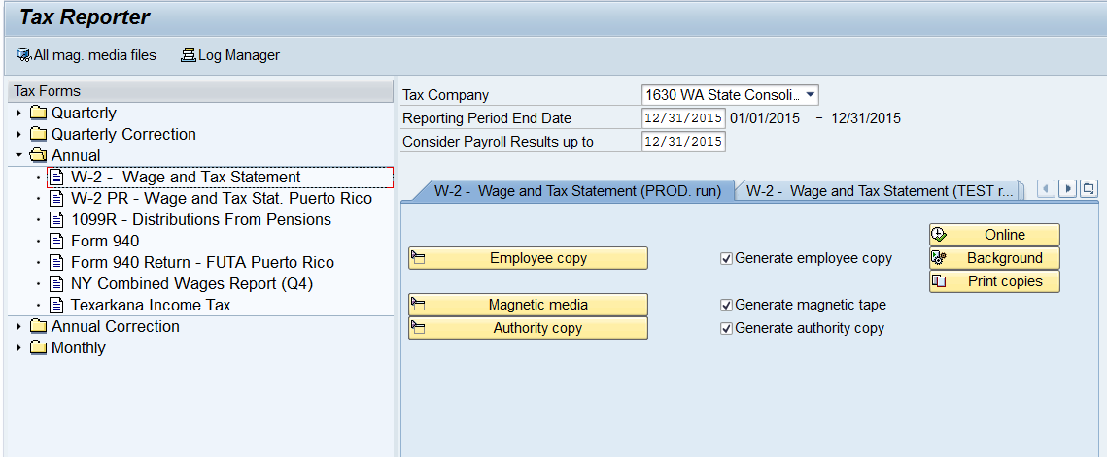

View Errors and Warnings, and Other Messages for W-2s

- Select the arrow in front of the Production category. (When running in test mode the same can be done by clicking the arrow in front of the Test category.) Samples from the Production W-2 process Tax Reporter Log Manager follow.
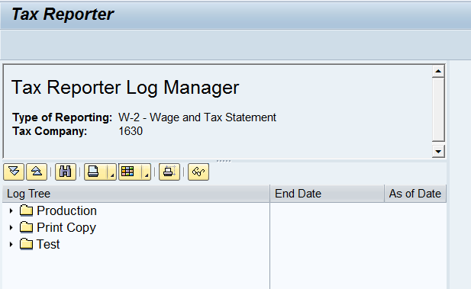

- Select the arrow of the Run Date you would like to view to see messages, errors and warnings.
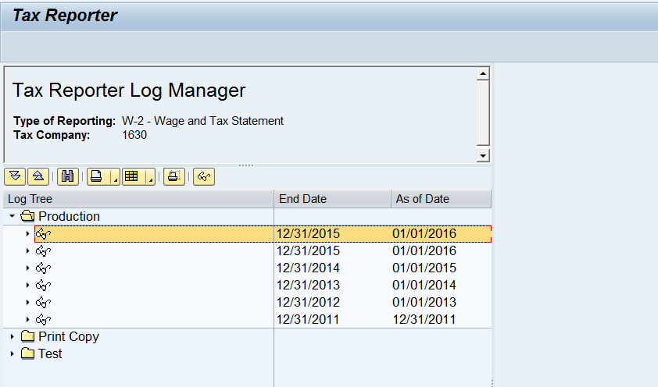

- To access any message area of the Tax Reporter Log Manager, double click on the category title, then double click on the specific message.
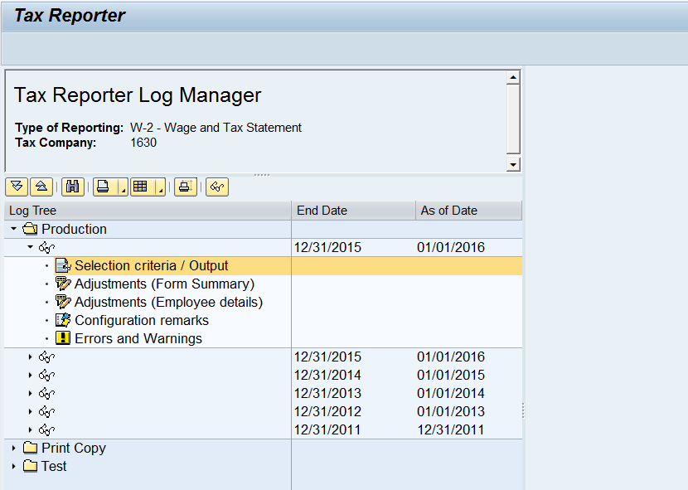

Examples: The following screen shots are examples of the different message categories accessible to locate potential problems. Please remember the message categories are Tax Company specific for each run; if there is no error or adjustment for the run, the category will not be available.

- Selection criteria/Output – review the selection criteria and the PDF based forms for that particular run.
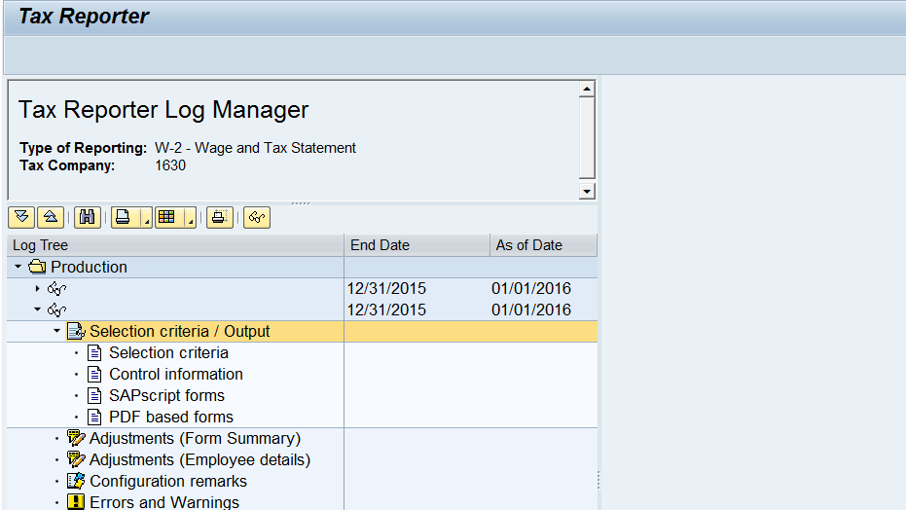

- Adjustments (Forms Summary) - a summary of what is listed in Adjustments (Employee details).
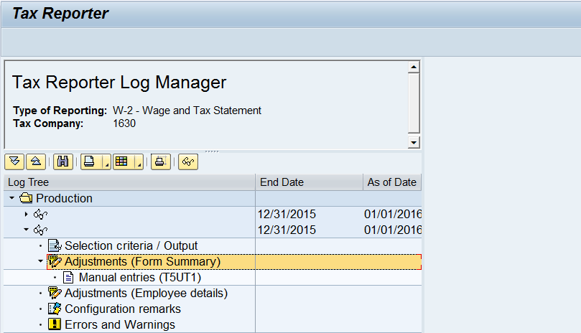

- Adjustments (Employee details) - review the messages generated in this section to determine if further action is needed.
  - EE’s with neg. wt /5PY: Double click on the message to view the impacted employees (This report will show the Tax co and the employees’ pernrs with negative /5PY value). No agency required for this message.
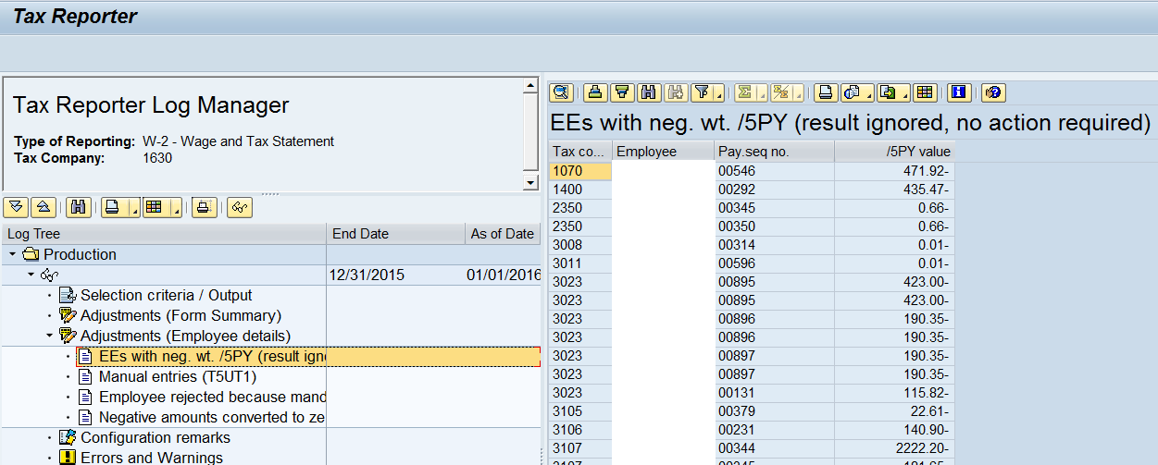
  - Manual entries (T5UT1): Double click on the message to view the impacted Employees (This report will show the Tax co and the employees’ pernrs with Manual entries). Agency action is to validate manual entries for PU19 were accurate.
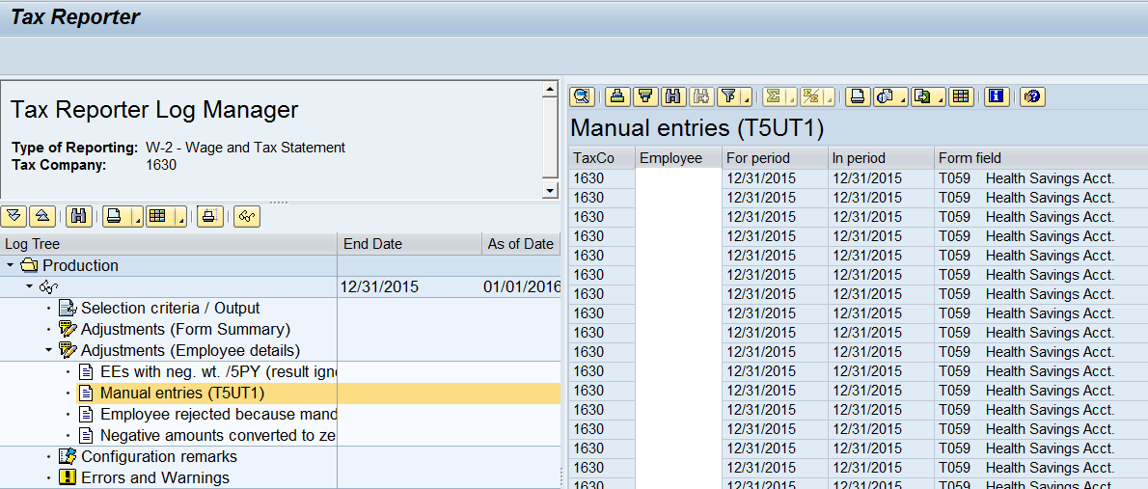
  - Employee rejected: Double click on the message to view the impacted employees (This report will show the Tax co and the employees’ pernrs that are rejected because mandatory field missing or negative). Agency action is to verify the W-2 information and master data for this employee. A W-2C and W-3C may be required depending on the data rejected.
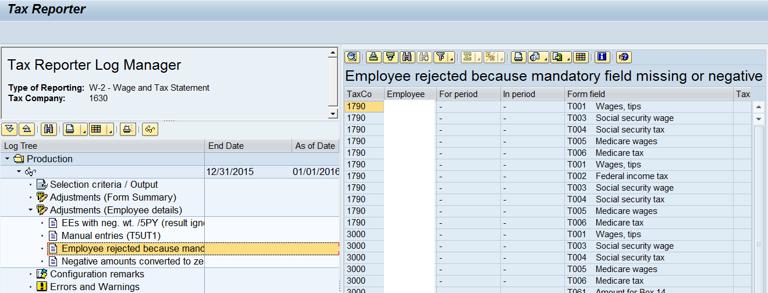
  - Negative amounts converted to zero: Double click on the message to view the impacted employees (This report will show the Tax co and the employees’ pernrs with Negative amounts converted to zero). No action normally required. Negative amounts are normally due to refunds of Insurance and Retirement deductions in the current year (originally paid in the prior year). Verify the W-2 information or if no W-2 for year, validate this is accurate.
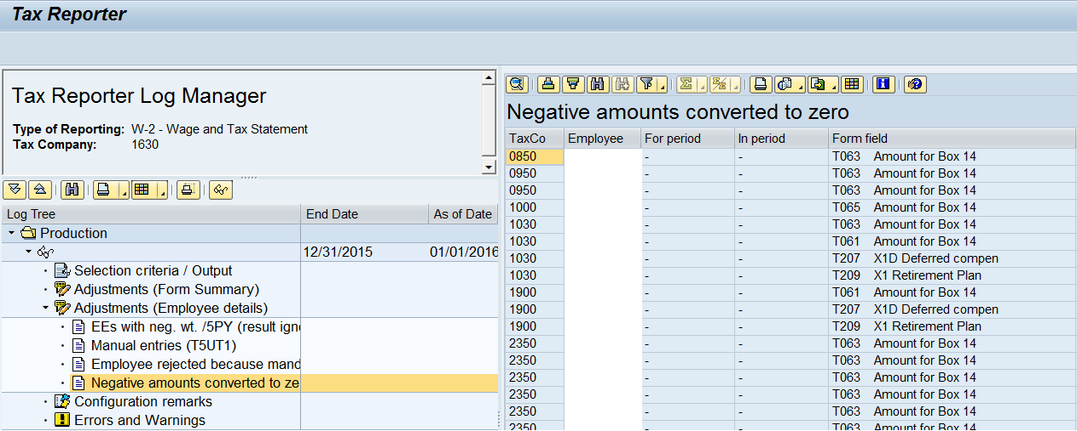

- Configuration remarks - this area has messages that are system related. No agency action required for these messages.
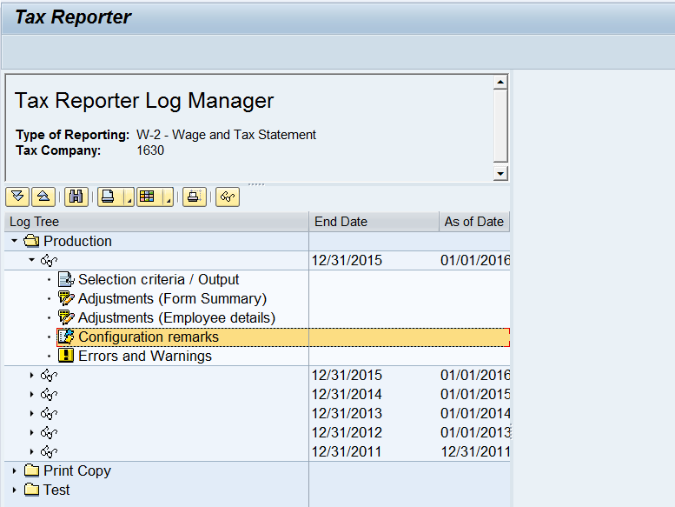

- Errors and Warnings - review the messages generated in this section to determine if further action is needed.
  - Employees with work site assigned from Infotype 209: Double click on the message to view the impacted employees. This is generally due to an employee have two infotype 209 records in the same year. No Agency Action required for this message.
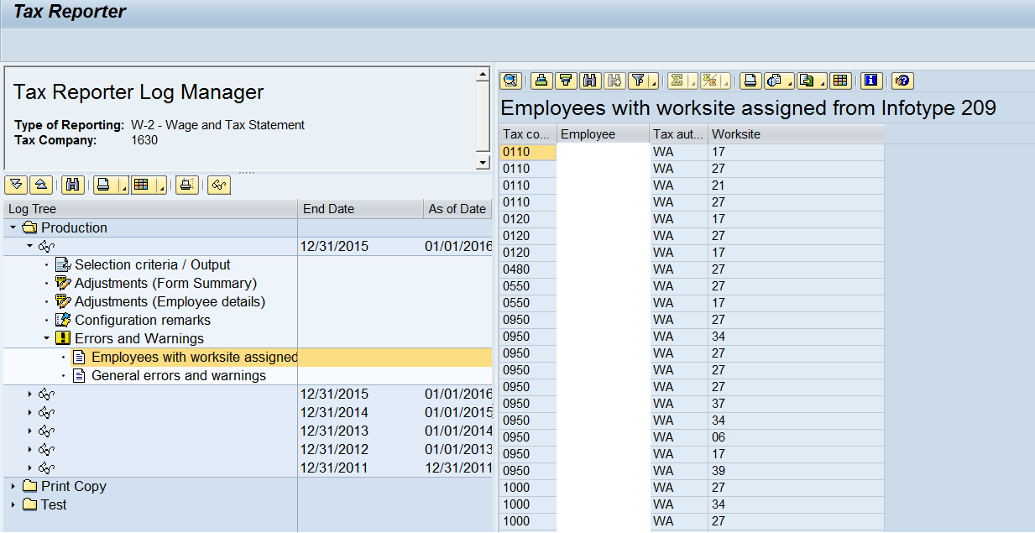
  - Employees with no W-2 related forms – this message means the employee had not reportable wages or has an exempt indicator set to ‘Y’ Exempt non-reportable.
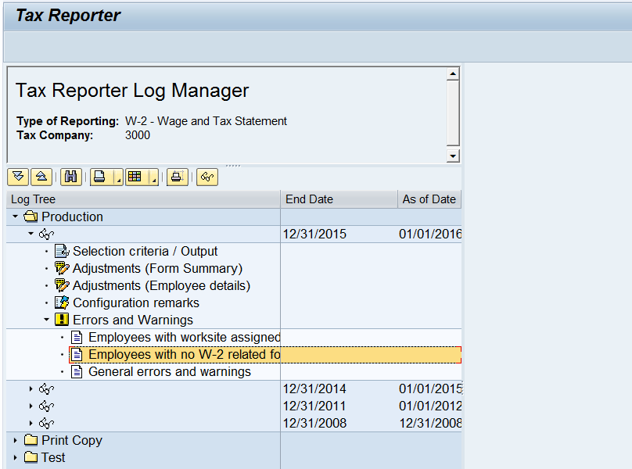
  - General errors and warnings: Double click on the message to view the impacted employees. The W-2 for employees listed with a general error message should be reviewed for accuracy.
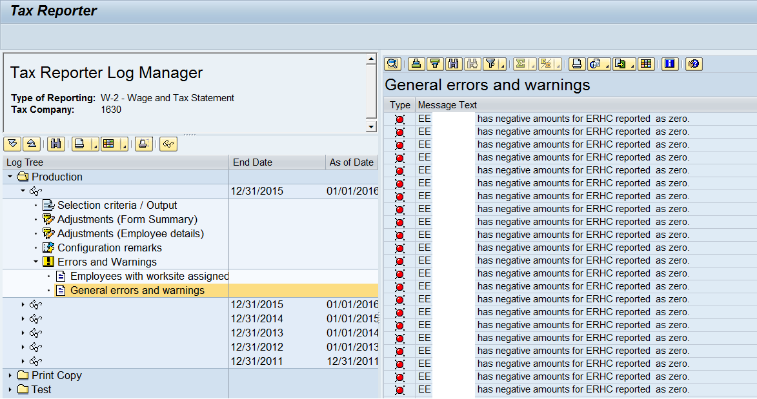
Sample error messages
    - EE 00009999 has negative amounts for ERHC reported as zero – this message is due to a manual PU19 adjustment for the Employer Health Care (Box 12), that caused a negative amount to be reported. Validate W-2 created is correct.
    - Retroactive Taxco change. EE# 00009999 Taxco: 9999 – this message means the employee had a retroactive tax company change during the reporting year. Validate W-2 created is correct.
    - Example: Taxco mis-match (Manual Entry vs IT 1). EE# 00009999 Taxco: 9999 – this message is due to the employee’s manual PU19 adjustment being created under an incorrect tax company. Validate W-2 created is correct.
    - Employee 00009999 not generated, No federal or state wages found – this message could be due to the employee truly having no reportable wages or a manual PU19 adjustment being created under an incorrect tax company. Validate W-2 created is correct.
    - Employee 00009999 rejected in form HR_F_W2 due to negative amount in TFF T### - this message could be due to a manual PU19 adjustment being created or master data updates that caused a negative amount to be reported. Validated W-2 was created and is correct.

W-2 Reissue
- Enter the appropriate Tax Company
- Enter date in Reporting Period End Date – 12/31/CCYY (ex: 2015)
- Enter date in Consider Payroll Results up to – 12/31/CCYY (ex: 2015)
- Select the arrow in front of Annual on the left side of the screen
- Select W-2 -Wage and Tax Statement
- Prior to executing any form in the Tax Reporter, review the Tax Reporter Log Manager to see if the form has already been run within the past seven days and is available to print from the Log Manager.
- Select tab labeled W-2 Wage and Tax Statement (PROD run)

Production screen will default with options that need to be deselected:

- Uncheck Generate magnetic tape and Generate authority copy
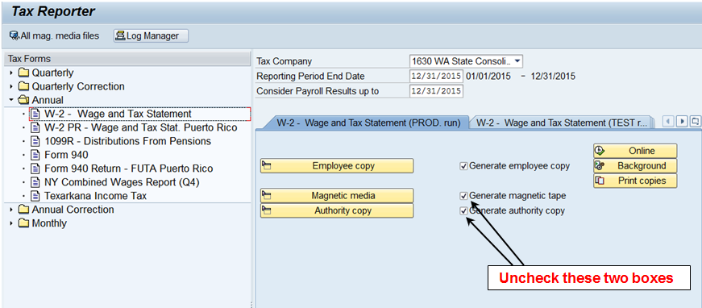

- Select Employee copy. Enter Personnel Numbers to be reissued. In Type of copy click radio button for Re-issue of Employee copy. Uncheck Generate Online W-2 Copy and Generate Audit Report
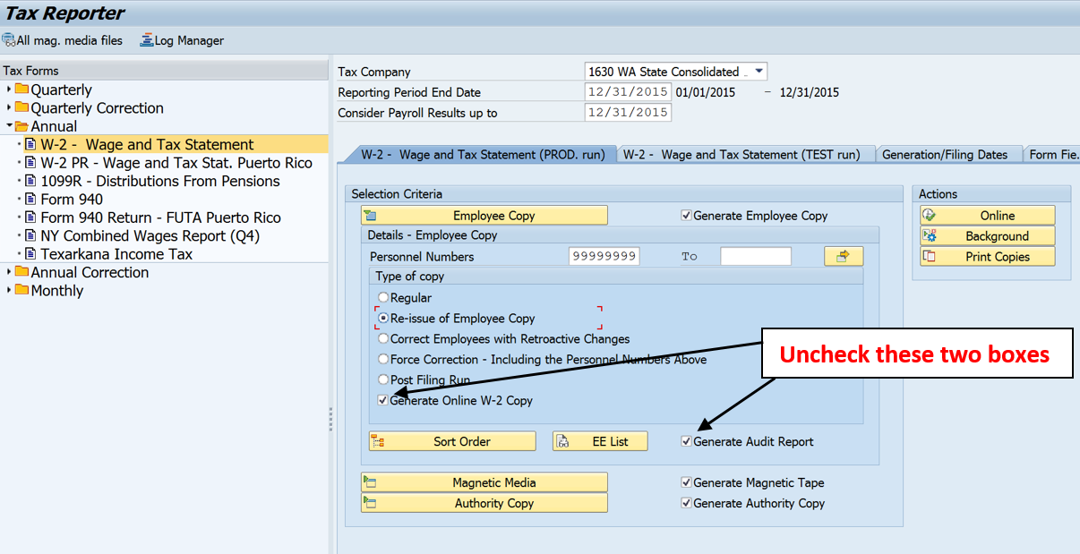

- Select the Magnetic media box, located below the Employee Copy selection area and Uncheck Generate form 6559.
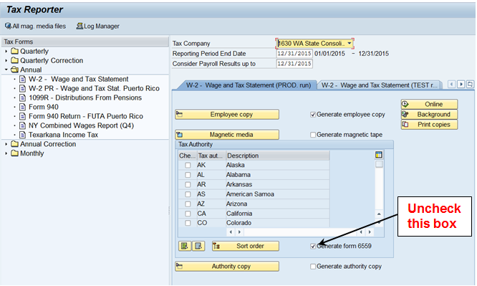

- Select the Authority copy box, located below the Magnetic media selection area. Uncheck Generate Form W3 and Generate summary copy
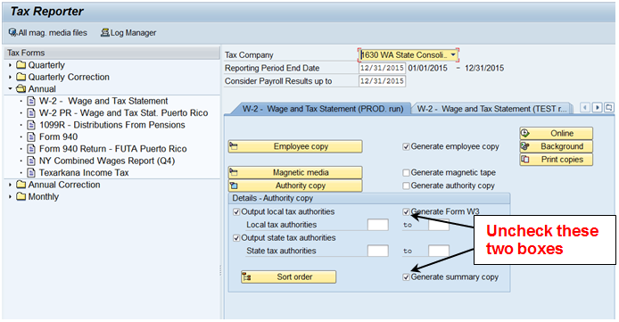

- Select on Print copies to the right of the selection area
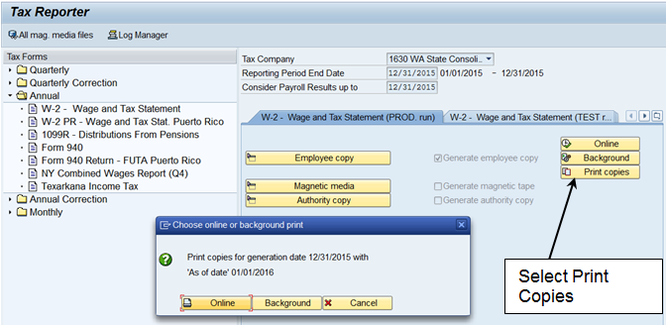
NOTE: A pop up window will appear, select Online if reissuing one or two W-2s and Background if reissuing multiple W-2s.

- If you have chosen Background the following screen will appear for submitting the job in the background. Click on Immediate and the Save button to submit the job.
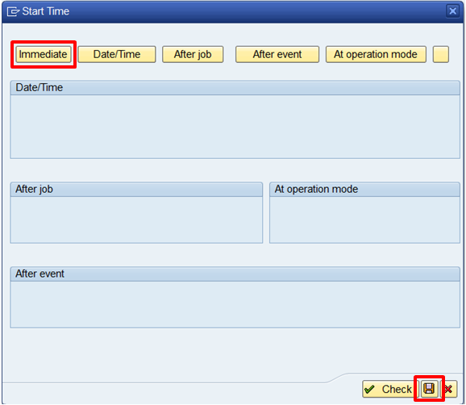

Open PDF Forms

If you ran the W-2 form(s) in the Background:
- Select Log Manager button above the Tax Forms area.
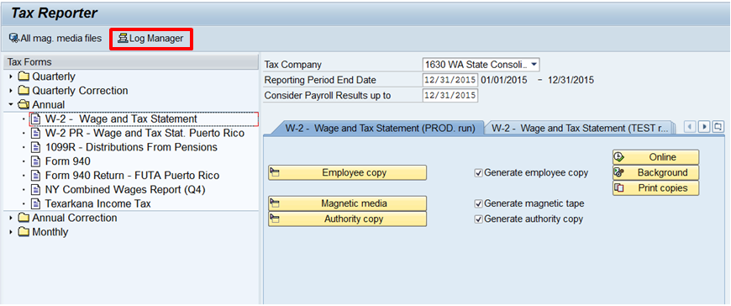

- Select the arrow next to Print Copy, then the arrow next to the W-2 form(s) that were ran in the Background and double click on Selection criteria/Output.
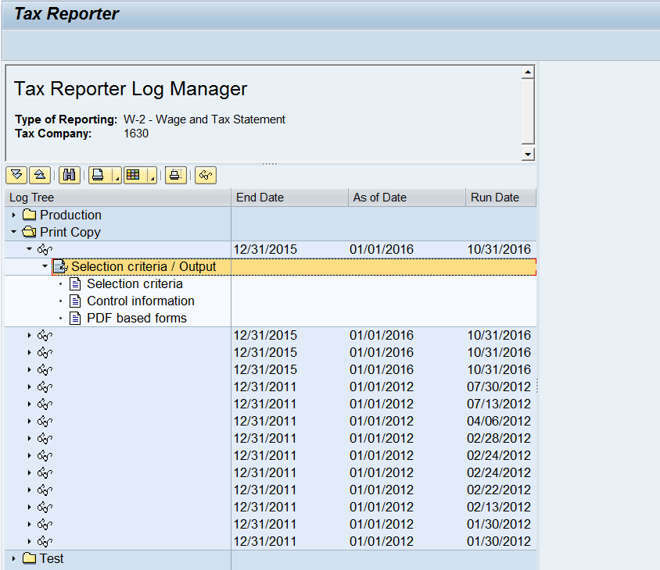

- Double click on PDF based forms and then select the spool number.
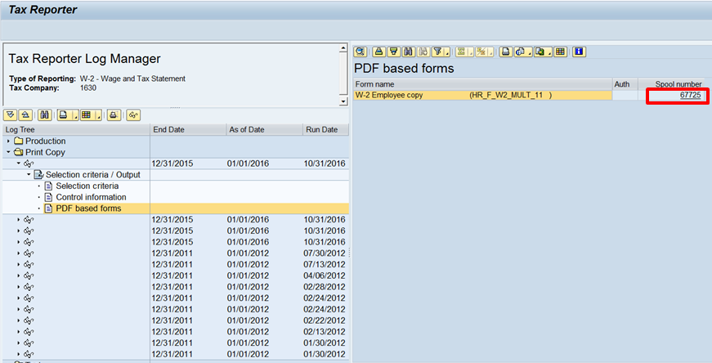

- You can now print the PDF.
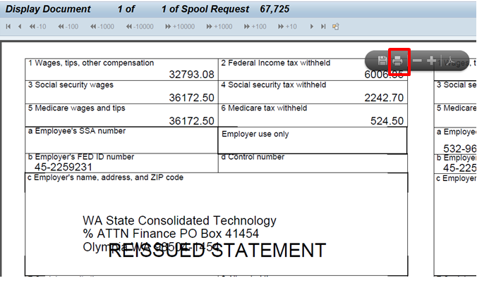

If you ran the W-2 form(s) Online
- Select the plus () in front of Forms to open the forms file, then double click on the title of the form you want to open.
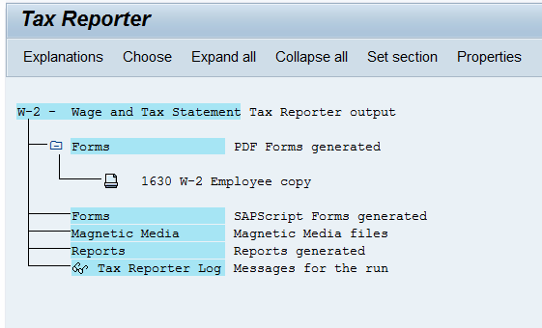

- You can now print the PDF.

NOTE: You will also need to provide the employee with the Notice to Employee (for the appropriate year) from the Year End website.

W-2 Audit Report
- Enter the appropriate Tax Company
- Enter date in Reporting Period End Date – 12/31/CCYY (ex: 2015)
- Enter date in Consider Payroll Results up to – 12/31/CCYY (ex: 2015)
- Select the arrow in front of Annual on the left side of the screen
- Select W-2 Wage and Tax Statement
- Select tab labeled W-2 Wage and Tax Statement (PROD run)

Production screen will default with options that need to be deselected:

- Uncheck Generate employee copy, Generate magnetic tape, and Generate authority copy.
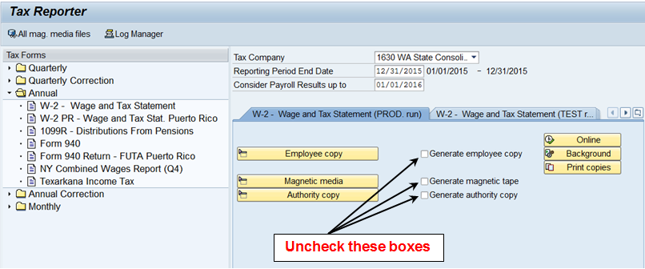

- Select Employee copy and be sure the Generate Audit Report is checked.
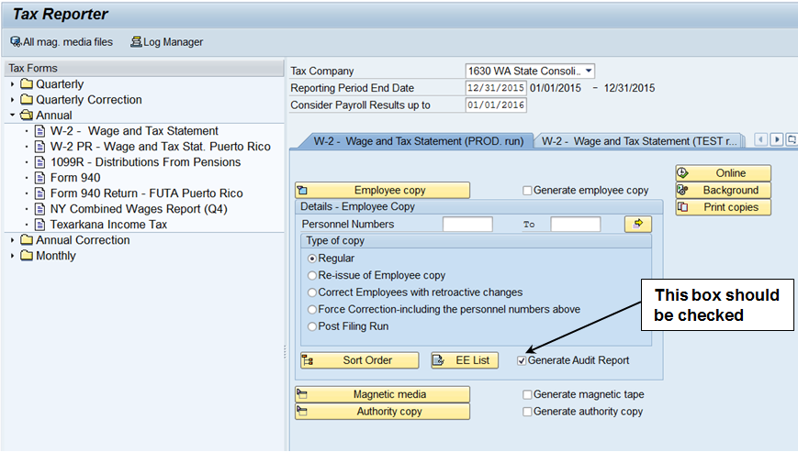

Select Sort Order button and define how you would like your report to display - default is by Personnel number

- After sort order has been completed, click the green check mark at the bottom of the Sorting Order window.
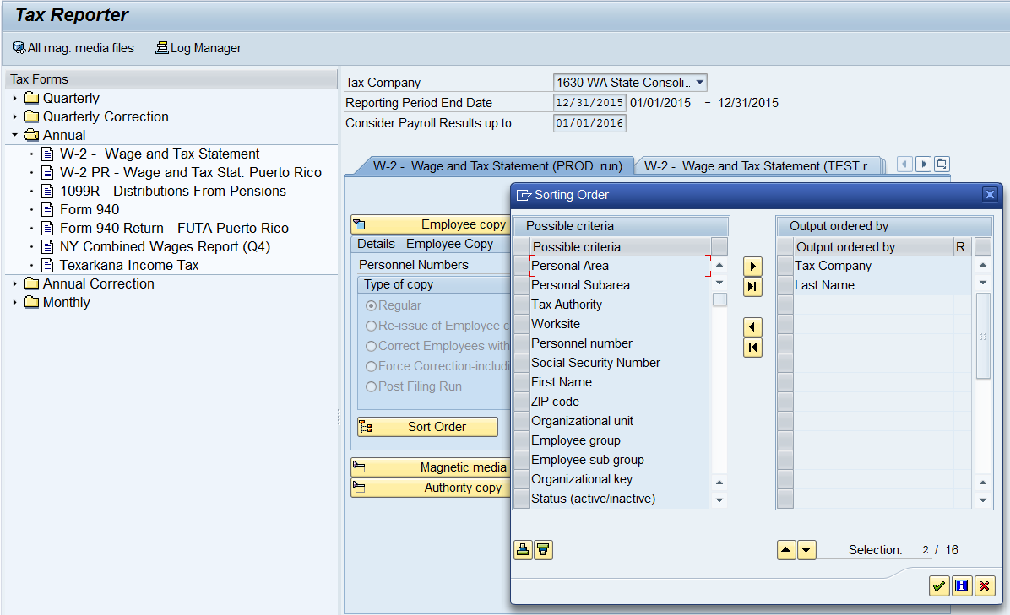

- Select Print copies, then the Online button.
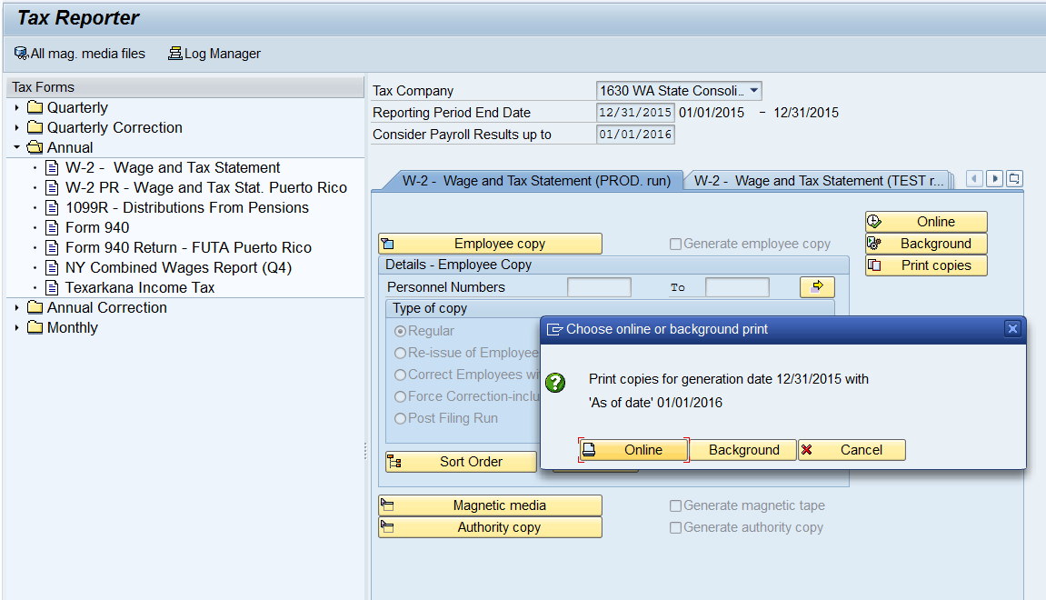

- Select the plus () in front of Forms to open the forms file, then double click on the title to view the W-2 Audit Report
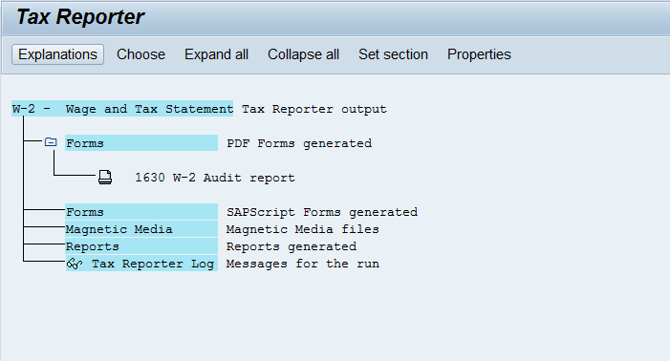

W-3 and Form 6559
- Enter the appropriate Tax Company
- Enter date in Reporting Period End Date – 12/31/CCYY (ex: 2016)
- Enter date in Consider Payroll Results up to – 12/31/CCYY (ex: 2016)
- Select the arrow in front of Annual on the left side of the screen
- Select W-2 Wage and Tax Statement
- Select tab labeled W-2 Wage and Tax Statement (PROD run)

Production Screen will default with options that need to be deselected:

- Uncheck Generate employee copy, Generate magnetic tape, and Generate authority copy.
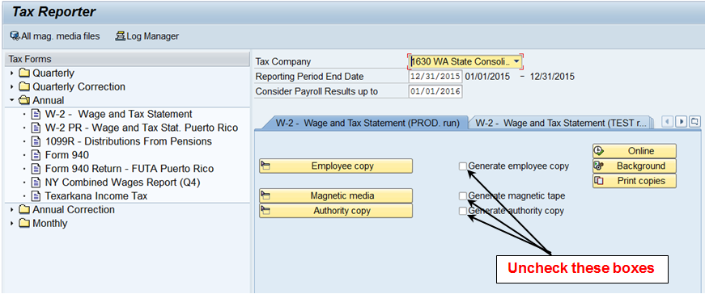

- Select Employee copy and Uncheck the Generate Audit Report
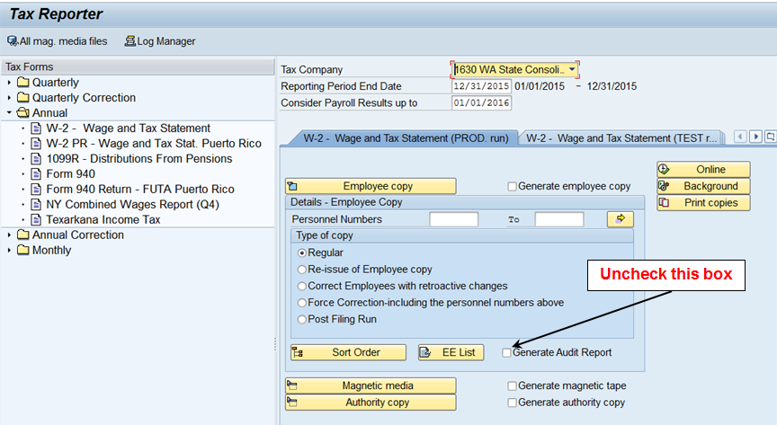

- Select Magnetic media and be sure the Generate form 6559 is selected
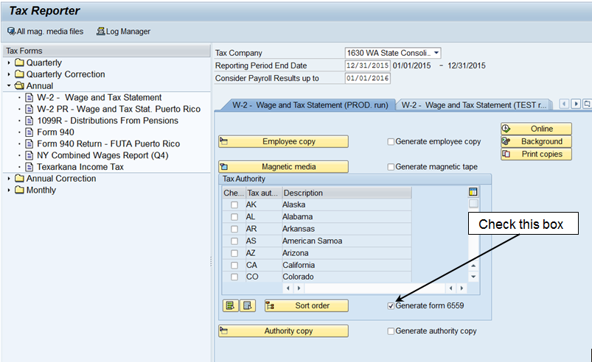

- Select Authority copy and be sure the Generate Form W3 is selected
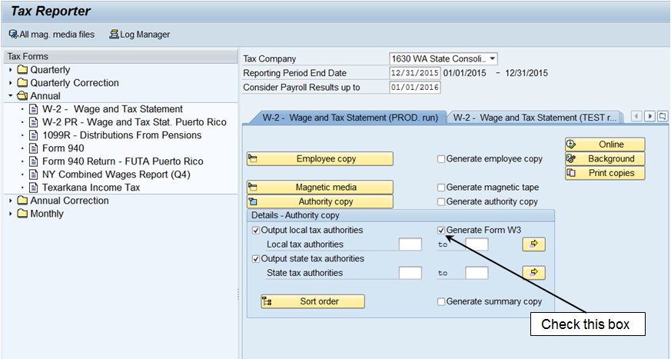

- Select Print Copies, then the Online button.
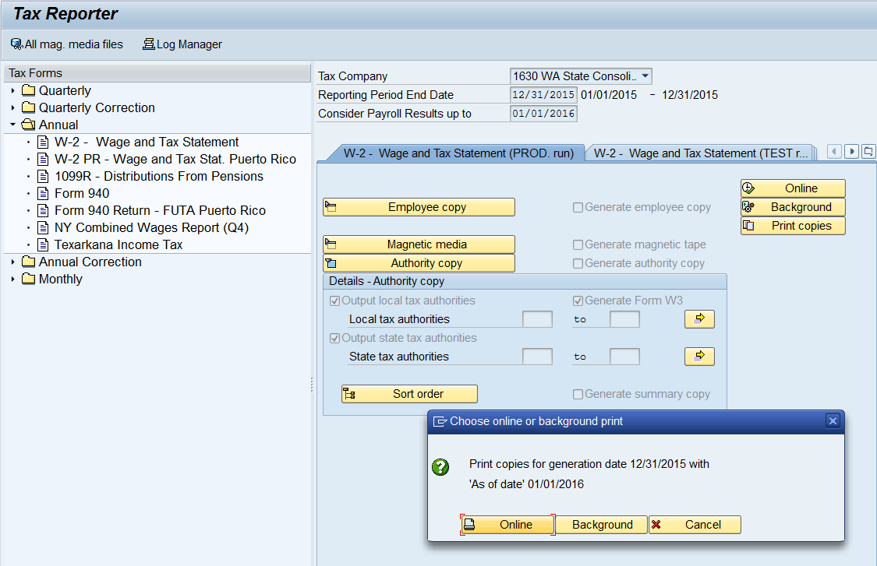

Check this box

- Select the plus () in front of Forms to open the forms file, then double click on the title to view/print the W-3 Form or 6559 Magnetic media summary.
