HRMS
Movement and Turnover Report
Use this procedure to identify when employees had movement between business areas, personnel areas, organizational units, job classes, or positions.

Roles: Personnel Administration Inquirer, Personnel Administration Processor, Personnel Administration Supervisor, Payroll Analyst, Payroll Inquirer, Payroll Processor, Payroll Supervisor, Financial Reporting Processor, Benefits Processor

Note: Field definitions can be accessed within HRMS by pressing the “F1” key on the keyboard, or via On Line Quick Reference (OLQR), HRMS Data Definitions Resource Guide, and Glossary.

- Enter transaction code “ZHR_RPTPYU26” in the Command field and click the “Enter” button () or press Enter on the keyboard | 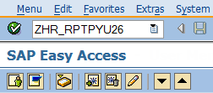
- The Movement and Turnover Report has four (4) selection areas to assist in filtering report results:  - Selection Criteria  - Report Behavior Options  - Action Behavior Options  - ALV Options | 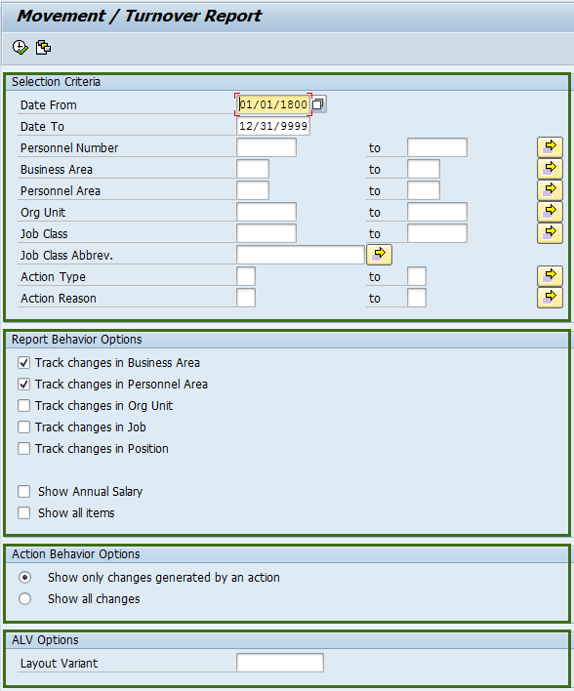
- Completing the “Selection Criteria” will assist in getting only information needed:  The following fields will default, but may be changed:  - Date From  - Date To  The following fields are optional:  - Personnel Number  - Business Area  - Personnel Area  - Organizational (Org) Unit  - Job Class  - Job Class Abbrev.  - Action Type  - Action Reason  - The “Report Behavior Options” contain seven (7) check boxes that determine what will display in the results.  The following fields will default as selected:  - Track changes in Business Area  - Track changes in Personnel Area  The following fields are optional:  - Track changes in Org Unit  - Track changes in Job  - Track changes in Position  - Show Annual Salary  - Show all items | 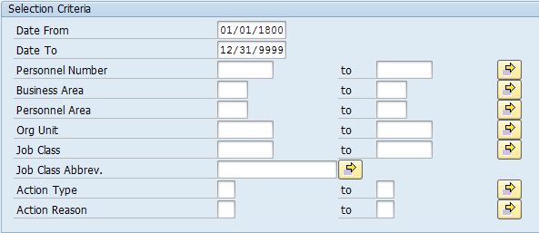  Stop – The Select Ranges function does not work for the Job Class Abbrev field. For multiple selections in the Job Class Abbrev. Field, enter each Job Class rather than using the Select Ranges function.  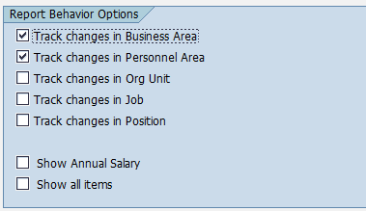  Tip  - Track changes in Business Area: Tracks movement between Business Areas.  - Track changes in Personnel Area: Tracks movement between Personnel Areas.  - Track changes in Org Unit: Tracks movement between Organizational Units.  - Track changes in Job: Tracks movement between Jobs.  - Track changes in Position: Tracks movement between Positions.  - Show Annual Salary: Displays Beginning and Ending salaries based on all above movement changes.  - Show all items: Displays all possible movement and report fields.  Caution  - HRMS security remains the same, no changes or enhancements have been made.  - Losing agencies will not be able to see the salary for other agencies.
- The “Action Behavior Options” contains the following two (2) radio buttons:  - Show only changes generated by an action  - Show all changes.  - Previously saved layout variants may be added to “ALV Options”. This field is optional.  - Click “Execute” button () or press F8 on the keyboard to run the Movement and Turnover Report | 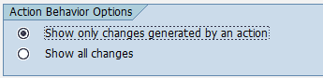  Tip  - Show only changes generated by an action: Defaults to only return records that were initiated by an action.  - Show all changes: Choose this option to return records generated by any change to Infotypes; Actions (IT0000), Organizational Assignment (IT0001), Planned Working Time (IT0007), or Basic Pay (IT0008).
- The standard results show eighteen (18) columns containing information for each move. If “Show Annual Salary” or “Show all items” were selected above, the results will display the New Annual Salary and Old Annual Salary columns as well. | 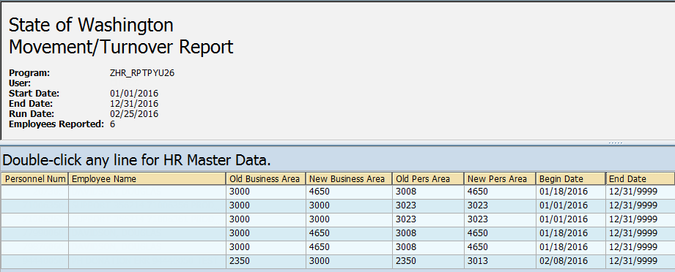  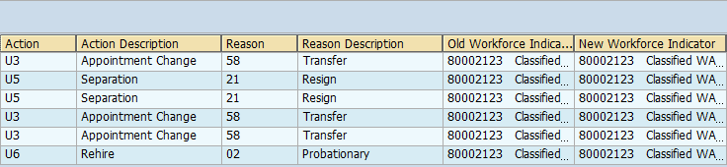  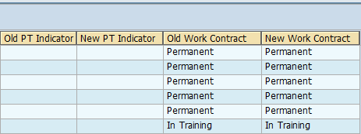  Tip  If all columns are not needed, a layout can be changed, saved or a previously saved layout can be selected.  - Change Layout: Click on the “Change Layout” button () to add, remove, or reorder columns, subtotals, or filters.  - Save Layout: After changing your report layout you can save it for future use by clicking the “Save Layout” button ().  - Select Layout: If a layout has been previously saved, you can retrieve it by clicking the “Select Layout” button () and selecting the layout.  Tip  Double clicking on any employee line in the report results screen will automatically take you to that employee’s PA20 master data screens. To return to the Movement and Turnover Report, click on the “Back Arrow” () one time.
- The table to the right maps each field to the Infotype.  - You have successfully completed the Movement and Turnover Report | 