HRMS
Position Duty Station Reports
Use this procedure to view two report selections for Position Duty Station. The report selections will provide duty station information for positions based on a key date or the history of duty station information for positions within a date range.

Effective 9/29/2016, modifications have been made to the position Address (1028) infotype to accommodate the required position duty station data. There will be minimal duty station data in HRMS for this report to pull information on prior to this date.
Roles: Personnel Administration Inquirer, Personnel Administration Processor, Personnel Administration Supervisor, Payroll Processor, Organizational Management Processor, and Organizational Management Inquirer.

Note: Field definitions can be accessed within HRMS by pressing the “F1” key on the keyboard, or via On Line Quick Reference (OLQR), HRMS Data Definitions Resource Guide, and Glossary.

- Enter transaction code “ZHR_RPTOMN04” in the Command field and click the “Enter” button () or press Enter on the keyboard | 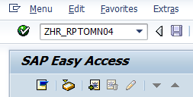
- The Position Duty Station Reports has five (5) selection areas to assist in filtering report results:  - Report Type Selection  - Period  - Position Selection Options  - Selection  - Output Format  - The “Report Type Selection” contains two (2) radio buttons that determine what will display in the results:  - Position Duty Station Data  - Position Duty Station Location History | 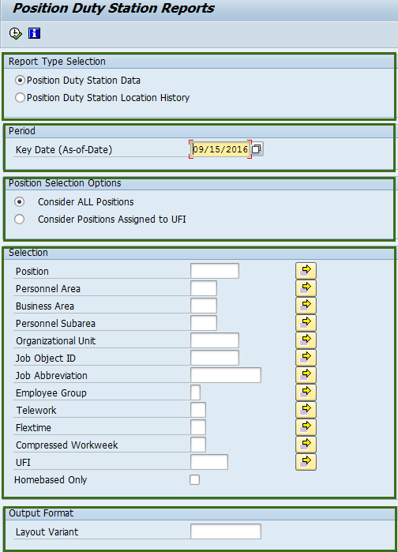  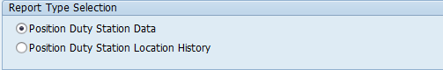  Tip  - The radio button will default to Position Duty Station Data, but may be changed.  - Position Duty Station Data is a report that will display all positions. The data displayed is based on the Key Date and selection criteria in the selection screen. Refer to Steps 4-11.  - Position Duty Station Location History is a report that will display the history or movement of position data. The data displayed is based on the Period and selection criteria entered in the selection screen. Refer to Steps 12-19.  - If there are attributes that changed during the selection date range, the report will pull multiple records showing the attributes with start and end dates of each attribute change.
- If Position Duty Station Data radio button is selected, the following fields will display on the report selection screen:  - Key Date (As-of-Date)  - Consider ALL position  - Consider Positions  Assigned to UFI  - Position  - Personnel Area  - Business Area  - Personnel Subarea  - Organization Unit  - Job Object ID  - Job Abbreviation  - Employee Group  - Telework  - Flextime  - Compressed Workweek  - UFI  - Homebased Only  - Layout Variant  - Enter date in Key Date (As-of-Date) field.  - The “Position Selection Options” contains two (2) radio buttons that will determine what will display in the results:  - Consider ALL Positions  - Consider Positions Assigned to UFI | 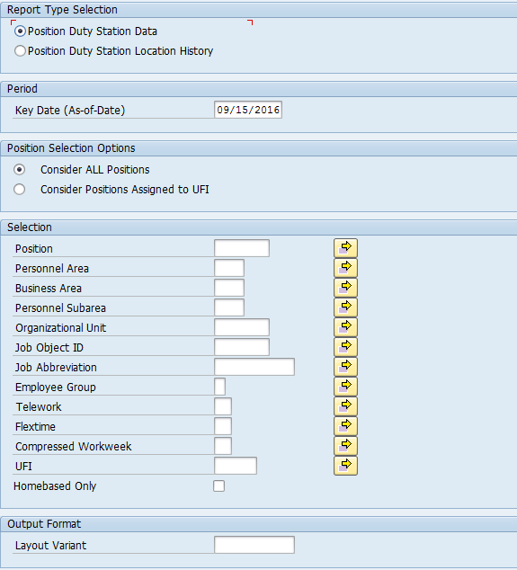  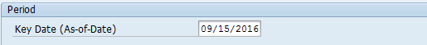  Tip  - Key Date (As-of-Date) field defaults to current date, but may be changed.  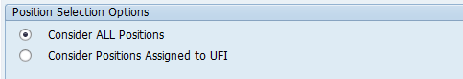  Tip  - The radio button will default to Consider ALL Positions, but may be changed.  - Consider ALL Positions will display all positions.  - This selection option can be used to identify positions that need to have a UFI code assigned.  - Consider Positions Assigned to UFI will display only positions that have an assigned UFI code on the Address (1028) infotype.
- Completing the “Selection” will assist in getting only information needed.  The following fields are optional:  - Position  - Personnel Area  - Business Area  - Personnel Subarea  - Organizational unit  - Job Object ID  - Job Abbreviation  - Employee Group  - Telework  - Flextime  - Compressed Workweek  - UFI  - Homebased Only  - Previously saved layout variants may be added to “Output Format”. This field is optional.  - Click “Execute” button () or press F8 on the keyboard to run the Position Duty Station Data report. | 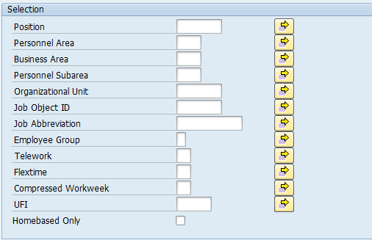  Tip  - UFI is a number that is assigned to all state facilities listed in the Facilities Inventory System. A list of UFI codes is available by clicking the match code in the UFI field.  - Homebased is when an employee is assigned to their home as the duty station. Homebased UFI codes start with a ‘Z’; for example, Z00231. If the Homebased field is checked, you will only get data for positions assigned to a Homebased UFI code.  - Job Abbreviation field is case sensitive.
- The standard results will show thirty-six (36) columns containing information.  - As of Date  - Position Code  - Position Abbr  - Position  - Business Area Code  - Business Area  - Personnel Area Code  - Personnel Area  - Personnel Subarea Code  - Personnel Subarea  - Organizational Unit Code  - Organization Unit Abbr  - Organization Unit  - Job Code  - Job Abbr  - Job  - Employee Group  - Unique Facility  Identifier  - Address 1  - Address 2  - City  - County  - State  - Zip Code-Zip4  - Country  - Active/Inactive UFI  - Vacant  - Telework (POS) Code  - Telework (POS)  - Flextime (POS) Code  - Flextime (POS)  - Compressed Workweek (POS) Code  - Compressed Workweek (POS)  - Homebased  - Workforce Indicator  - Position Count | 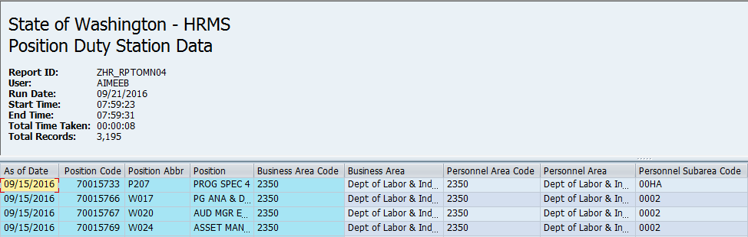  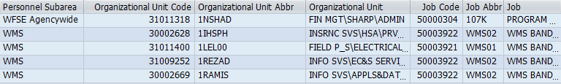  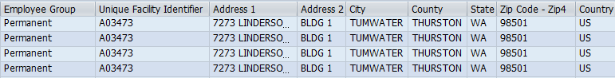  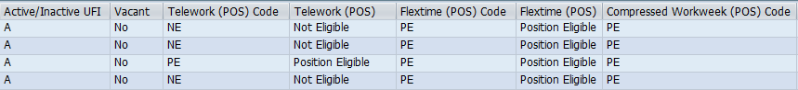  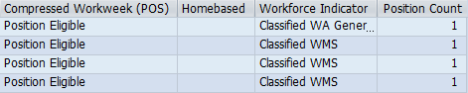  Tip  - The full column names will display when you hover the cursor over the column headings.  - As of Date is the key date entered on the selection screen.  If all columns are not needed, a layout can be changed, saved or a previously saved layout can be selected.  - Change Layout: Click on the “Change Layout” button () to add, remove, or reorder columns, subtotals, or filters.  - Save Layout: After changing your report layout you can save it for future use by clicking the “Save Layout” button ().  - Select Layout: If a layout has been previously saved, you can retrieve it by clicking the “Select Layout” button () and selecting the layout.
- You have successfully completed the Position Duty Station Data report.  - If Position Duty Station Location History radio button is selected, the following fields will display:  - Period  - Consider ALL Positions  - Consider Positions  Assigned to UFI  - Position  - Personnel Area  - Business Area  - Personnel Subarea  - Organizational Unit  - Job Object ID  - Job Abbreviation  - Employee Group  - UFI  - Layout Variant  - Enter from date and to date in Period field. | 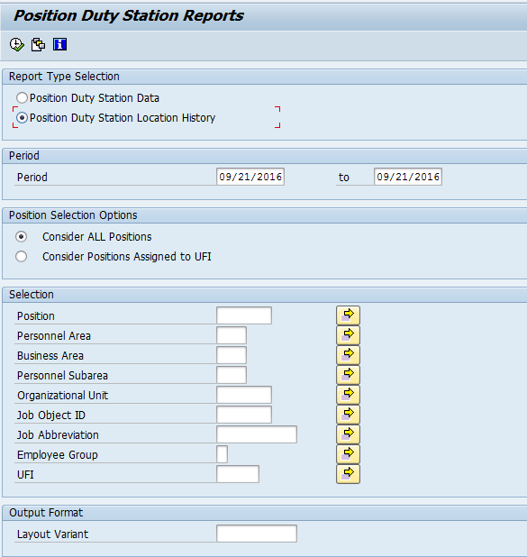  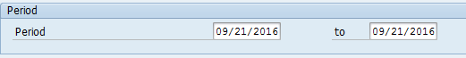  Tip  - Period dates will default to current dates, but may be changed.
- The “Position Selection Options” contains two (2) radio buttons that will determine what will display in the results:  - Consider ALL Positions  - Consider Positions Assigned to UFI  - Completing the “Selection” will assist in getting only information needed.  The following fields are optional:  - Position  - Personnel Area  - Business Area  - Personnel Subarea  - Organization Unit  - Job Object ID  - Job Abbreviation  - Employee Group  - UFI  - Previously saved layout variants may be added to “Output Format”. This field is optional.  - Click “Execute” button  () or press F8 on the keyboard to run the Position Duty Station Location History report. | Tip  - The radio button will default to Consider ALL Positions, but may be changed.  - Consider ALL Positions will display all positions.  - This selection option can be used to identify positions that need to have a UFI code assigned.  - Consider Positions Assigned to UFI will display only positions that have an assigned UFI code on the Address (1028) infotype.  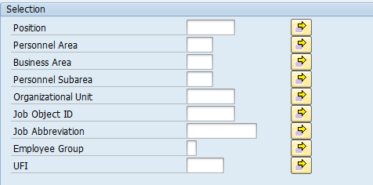  Tip  - UFI is a number that is assigned to all state facilities listed in the Facilities Inventory System. A list of UFI codes is available by clicking the match code in the UFI field.  - Job Abbreviation field is case sensitive.
- The standard results will show twenty-eight (28) columns containing information.  - Unique Facility Identifier  - Begin Date  - End Date  - Position Code  - Position Abbr  - Position  - Business Area Code  - Business Area  - Personnel Area Code  - Personnel Area  - Personnel Subarea Code  - Personnel Subarea  - Organization Unit Code  - Organization Unit Abbr  - Organization Unit  - Job Code  - Job Abbr  - Job  - Employee Group  - Address 1  - Address 2  - City  - County  - State  - Zip Code-Zip4  - Country  - Active/Inactive UFI  - Workforce Indicator  - You have successfully completed the Position Duty Station Location History report. | 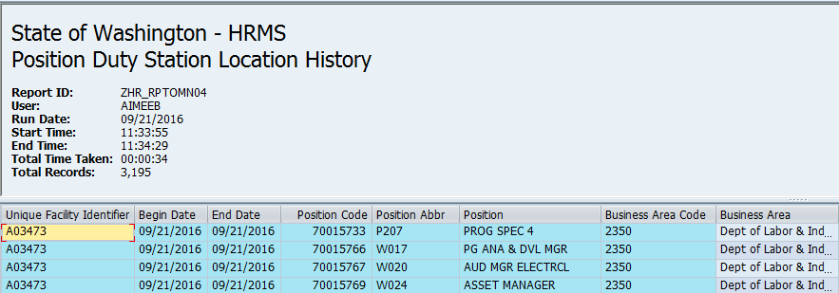  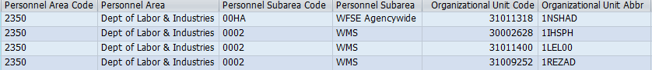  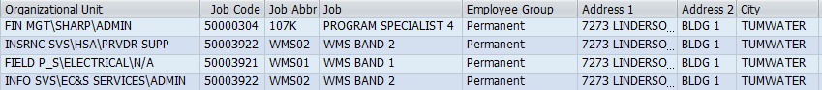  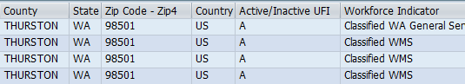  Tip  - The full column names will display when you hover the cursor over the column headings.  - Begin Date and End Date are the dates entered on the selection screen.  If all columns are not needed, a layout can be changed, saved or a previously saved layout can be selected.  - Change Layout: Click on the “Change Layout” button () to add, remove, or reorder columns, subtotals, or filters. Columns added with ZDNU, will not display data.  - Save Layout: After changing your report layout you can save it for future use by clicking the “Save Layout” button ().  - Select Layout: If a layout has been previously saved, you can retrieve it by clicking the “Select Layout” button () and selecting the layout.

