HRMS
Employee Duty Station Reports
Use this procedure to view two report selections for Employee Duty Station. The report selections will provide duty station information for employees based on a key date or the history of duty station information for employees within a date range.

Roles: Personnel Administration Inquirer, Personnel Administration Processor, Personnel Administration Supervisor, Payroll Processor, Organizational Management Processor, and Organizational Management Inquirer.

Note: Field definitions can be accessed within HRMS by pressing the “F1” key on the keyboard, or via On Line Quick Reference (OLQR), HRMS Data Definitions Resource Guide, and Glossary.

- Enter transaction code “ZHR_RPTPA805” in the Command field and click the “Enter” button () or press Enter on the keyboard | 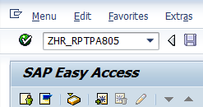
- The Employee Duty Station Reports has four (4) selection areas to assist in filtering report results:  - Report Type Selection  - Period  - Selection  - Output Format | 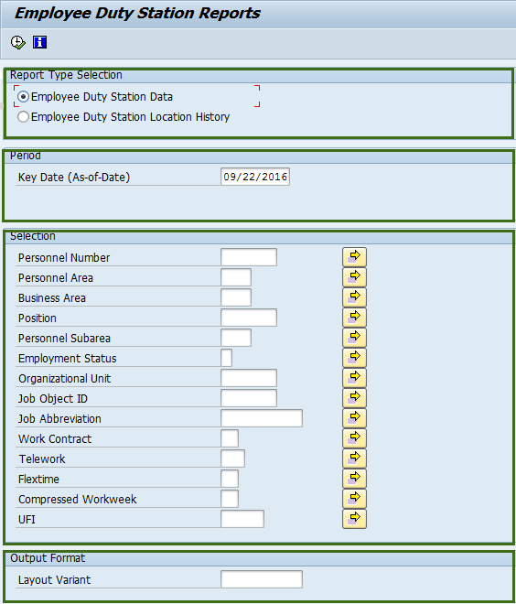
- The “Report Type Selection” contains two (2) radio buttons that will determine what will display in the results:  - Employee Duty Station Data  - Employee Duty Station Location History  - If Employee Duty Station Data radio button is selected, the following fields will display on the report selection screen:  - Key Date (As-of-Date)  - Personnel Number  - Personnel Area  - Business Area  - Position  - Personnel Subarea  - Employment Status  - Organizational Unit  - Job Object ID  - Job Abbreviation  - Work Contract  - Telework  - Flextime  - Compressed Workweek  - UFI  - Layout Variant | 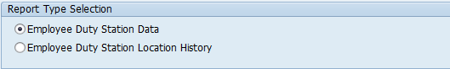  Tip  - The radio button will default to Employee Duty Station Data, but may be changed.  - Employee Duty Station Data is a report that will display all employees. The data displayed is based on the Key Date and selection criteria in the selection screen. Refer to Steps 4-10.  - Employee Duty Station Location History is a report that will display the history or movement of employee data. The data displayed is based on the Period and selection criteria entered in the selection screen. Refer to Steps 11-18.  - If there are attributes that changed during the selection date range, the report will pull multiple records showing the attributes with start and end dates of each attribute change.  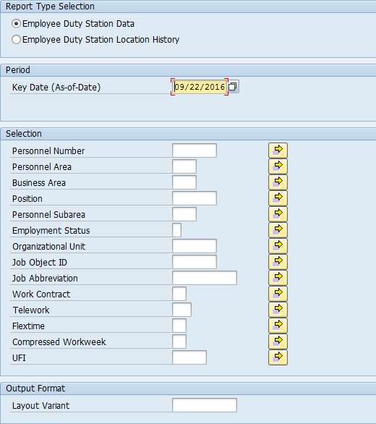
- Enter date in Key Date (As-of-Date) field.  - Completing the “Selection” will assist in getting only information needed.  The following fields are optional:  - Personnel Number  - Personnel Area  - Business Area  - Position  - Personnel Subarea  - Employment Status  - Organizational Unit  - Job Object ID  - Job Abbreviation  - Work Contract  - Telework  - Flextime  - Compressed Workweek  - UFI  - Previously saved layout variants may be added to “Output Format”. This field is optional.  - Click “Execute” button () or press F8 on the keyboard to run the Employee Duty Station Data report. | 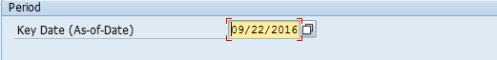  Tip  - Key Date (As-of-Date) field defaults to current date, but may be changed.  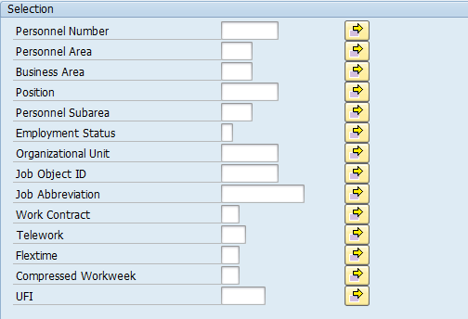  Tip  - UFI is a number that is assigned to all state facilities listed in the Facilities Inventory System. A list of UFI codes are available by clicking the match code in the UFI field.  - Job Abbreviation field is case sensitive.
- The standard results will show thirty-eight (38) columns containing information.  - As of Date  - Personnel Number  - Employee Name  - Business Area Code  - Business Area  - Personnel Area Code  - Personnel Area  - Personnel Subarea Code  - Personnel Subarea  - Position Code  - Position Abbr  - Position  - Organization Unit Code  - Organization Unit Abbr  - Organization Unit  - Job Code  - Job Abbr  - Job  - Work Contract  - Position UFI Override  - Unique Facility Identifier  - Address 1  - Address 2  - City  - County  - State  - Zip Code-Zip4  - Country  - Active/Inactive UFI  - Telework (EE) Code  - Telework (EE)  - Flextime (EE) Code  - Flextime (EE)  - Compressed Workweek (EE) Code  - Compressed Workweek (EE)  - Homebased  - Capacity Util. Level  - Employee Count | 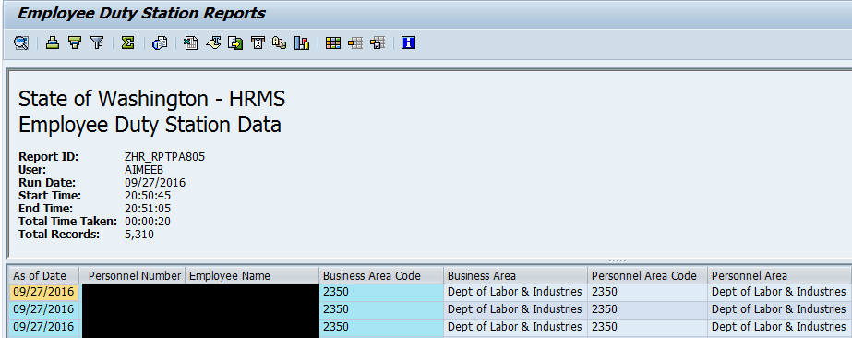  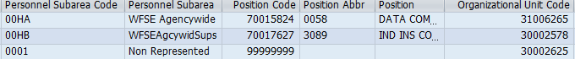  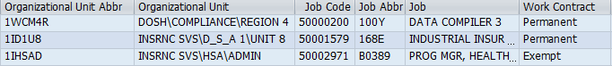  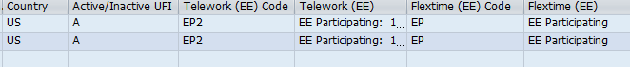  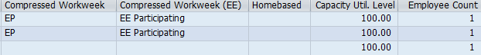  Tip  - The full column names will display when you hover the cursor over the column headings.  - As of Date is the key date entered on the selection screen.  - If the Position UFI Override column has an X in the box, the Duty Station Data is coming from the Duty Station Address (9105) infotype.  - If the Position UFI Override column does not display an X, the data is coming from the employee’s assigned position’s Address (1028) infotype.
- You have successfully completed the Employee Duty Station Data report.  - If Employee Duty Station Location History radio button is selected, the following fields will display:  - Period  - Compress Data-Generates Unique Lines of Data  - Show all Data- Generates All Lines of Data  - Personnel Number  - Personnel Area  - Business Area  - Position  - Personnel Subarea  - Employment Status  - Organizational Unit  - Job Object ID  - Job Abbreviation  - Work Contract  - Telework  - Flextime  - Compressed Workweek  - UFI  - Layout Variant | Tip  If all columns are not needed, a layout can be changed, saved or a previously saved layout can be selected.  - Change Layout: Click on the “Change Layout” button () to add, remove, or reorder columns, subtotals, or filters.  - Save Layout: After changing your report layout you can save it for future use by clicking the “Save Layout” button ().  - Select Layout: If a layout has been previously saved, you can retrieve it by clicking the “Select Layout” button () and selecting the layout.  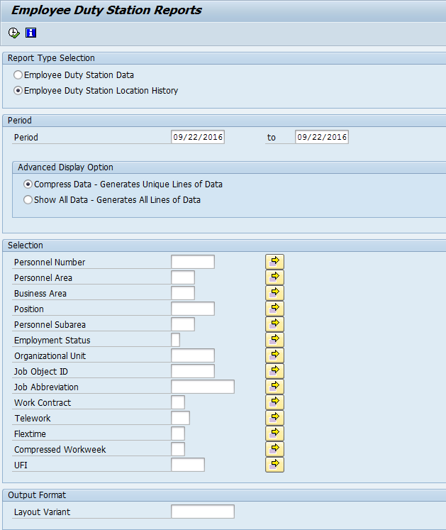

- Enter from date and to date in Period field.  - The “Advance Display Option” contains two (2) radio buttons that will determine what will display in the results:  - Compress Data- Generates Unique Lines of Data  - Show All Data- Generates All Lines of Data | 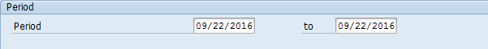  Tip  - Period dates will default to current dates, but may be changed.  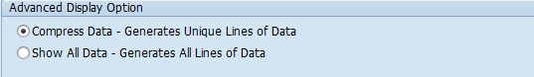  Tip  - The radio button will default to Compress Data – Generates Unique Lines of Data, but may be changed.  - Compress Data – Generates Unique Lines of Data will pull data from several infotypes. The compressed data option will only display changes in the rows of data that are in the columns displayed in the report results. Example: There is an update to the Time Administrator field on the Organizational Assignment (0001) infotype. This field is not displayed in the report results. The report will not insert another row of data with the start date of the Time Administrator field update.  - Show All Data – Generates All Lines of Data will pull data from several infotypes. The show all data option will display rows of data if there was a change made on one of the infotypes even if the field is not displayed on the report. Example: There is an update to the Time Administrator field on the Organizational Assignment (0001) infotype. This field is not displayed in the report results. The report will insert another row of data with the start date of the Time Administrator field update. Other than the start date, the data displayed in the report result columns will remain the same.
- Completing the “Selection” will assist in getting only information needed.  The following fields are optional:  - Personnel Number  - Personnel Area  - Business Area  - Position  - Personnel Subarea  - Employment Status  - Organizational Unit  - Job Object ID  - Job Abbreviation  - Work Contract  - Telework  - Flextime  - Compressed Workweek  - UFI  - Previously saved layout variants may be added to “Output Format”. This field is optional.  - Click “Execute” button  () or press F8 on the keyboard to run the Employee Duty Station Location History report. | 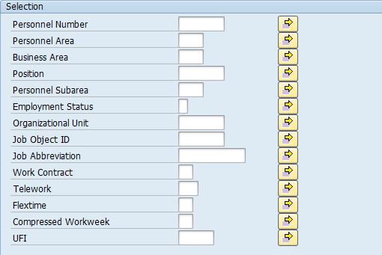  Tip  - UFI is a number that is assigned to all state facilities listed in the Facilities Inventory System. A list of UFI codes are available by clicking the match code in the UFI field.  - Job Abbreviation field is case sensitive.
- The standard results will show thirty-eight (38) columns containing information.  - Unique Facility Identifier  - Begin Date  - End Date  - Personnel Number  - Employee Name  - Business Area Code  - Business Area  - Personnel Area Code  - Personnel Area  - Personnel Subarea Code  - Personnel Subarea  - Position Code  - Position Abbr  - Position  - Organizational Unit Code  - Organization Unit Abbr  - Organization Unit  - Job Code  - Job Abbr  - Job  - Work Contract  - Address 1  - Address 2  - City  - County  - State  - Zip Code-Zip4  - Country  - Active/Inactive UFI  - Position UFI Override  - Telework (EE) Code  - Telework (EE)  - Flextime (EE) Code  - Flextime (EE)  - Compressed Workweek (EE) Code  - Compressed Workweek (EE)  - Homebased  - Capacity Util. Level  - You have successfully completed the Employee Duty Station Location History report. | 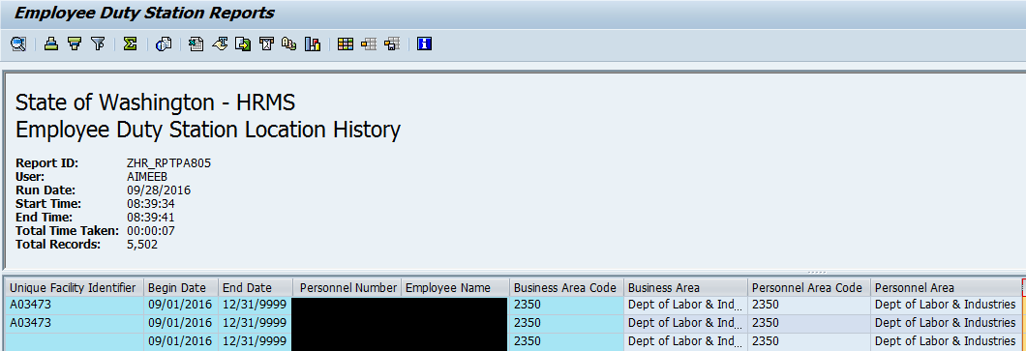  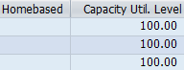  Tip  - The full column names will display when you hover the cursor over the column headings.  - Begin Date and End Date are the dates entered on the selection screen.  - If the Position UFI Override column has an X in the box, the Duty Station Data is coming from the Duty Station Address (9105) infotype.  - If the UFI Override column does not display an X, the data is coming from the employee’s assigned position’s Address (1028) infotype.

- You have successfully completed the Employee Duty Station Location History report. | Tip  If all columns are not needed, a layout can be changed, saved or a previously saved layout can be selected.  - Change Layout: Click on the “Change Layout” button () to add, remove, or reorder columns, subtotals, or filters. Columns added with ZDNU, will not display data.  - Save Layout: After changing your report layout you can save it for future use by clicking the “Save Layout” button ().  - Select Layout: If a layout has been previously saved, you can retrieve it by clicking the “Select Layout” button () and selecting the layout.

