Helpful Hints – Suggested Series of Transaction Codes for Payroll Processing

These transaction codes are sequentially organized by Day, from pre-Day 0 through Day 4, and are provided as an aid to agencies.

To save these to your HRMS Favorites:
Create Folders:
In HRMS, on the SAP Easy Access screen, right-click on Favorites and select Insert Folder; name the folder (i.e. Payroll Processing).
Green Check
Add additional folders and sub-folders as needed (i.e. Pre Day 0)

Add Transaction Codes:
Right-click on desired folder/sub-folder and select Insert Transaction.
In the Manual Entry of a Transaction window, enter a Transaction Code as shown in the screen prints on pages 2 and 3 below (i.e. PUOC_10).
Green check.
Add additional Transaction Codes as needed.

**For additional instructions, see Course Manual for HRMS Basics and Reporting

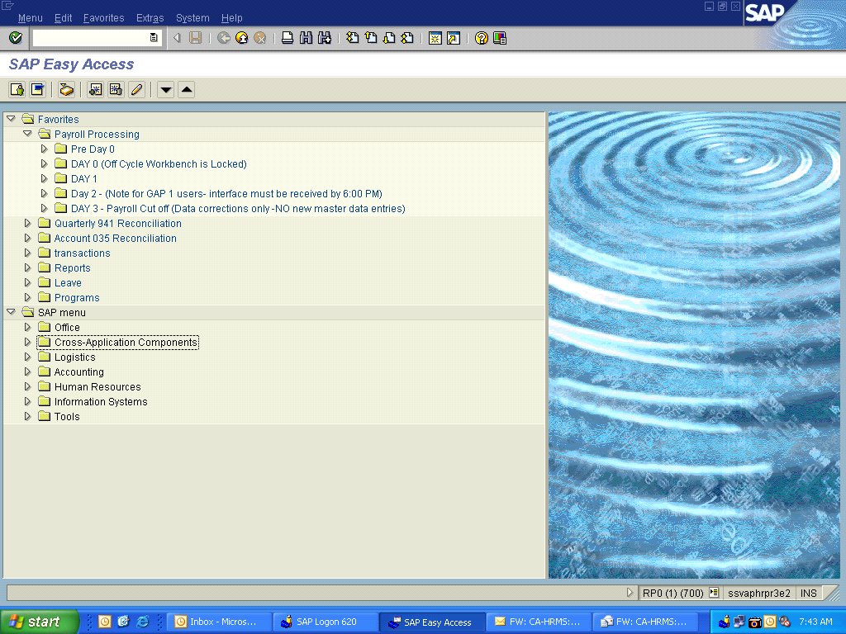

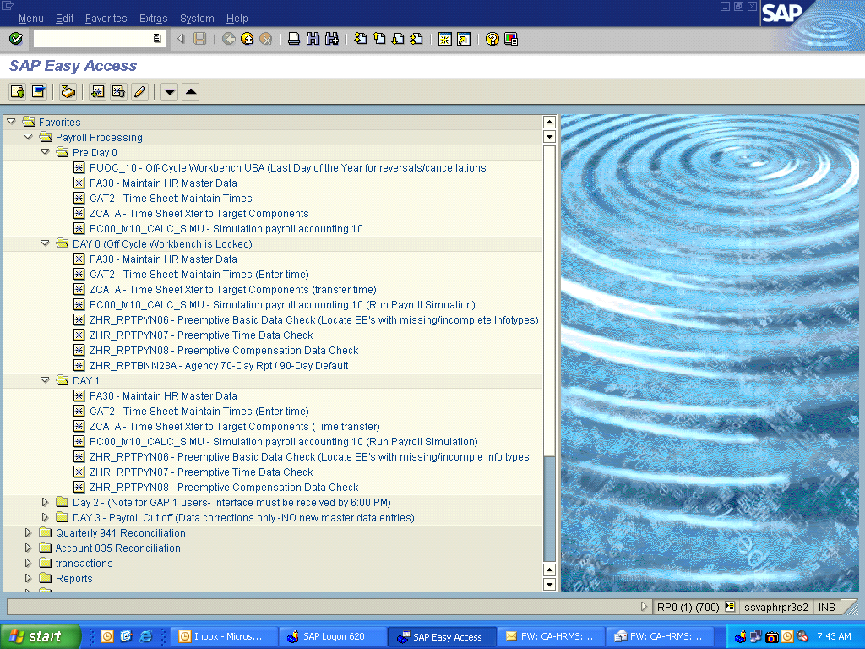

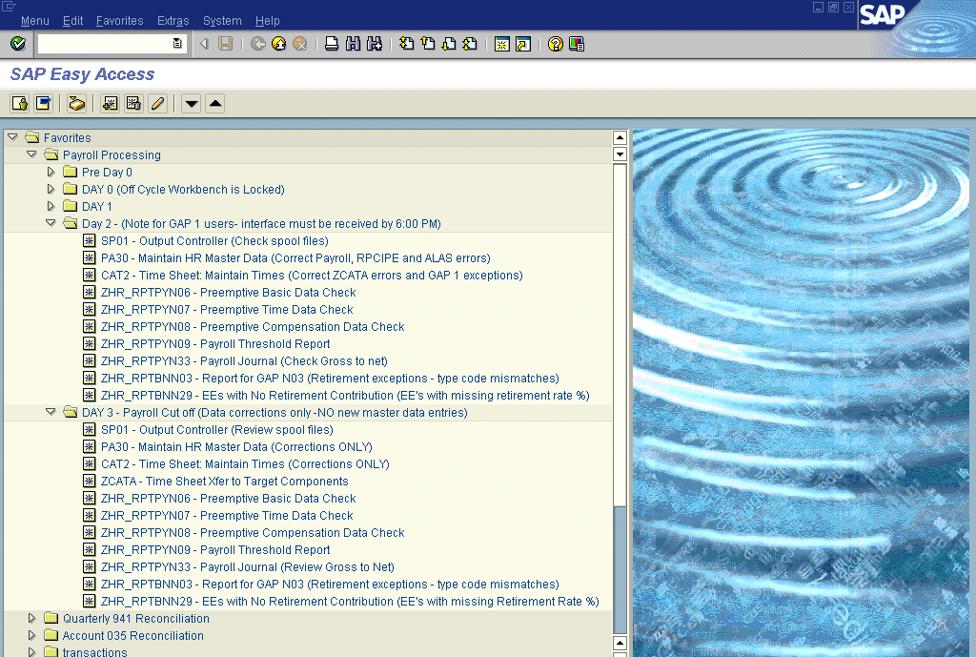

Day 0:

- Run Corrections and Returns ZHR_RPTPY151 to find any direct deposits that will not clear; notify employee they will receive a warrant.

Day 1:
- Enter Time (CAT2) and transfer ZCATA
- Run Payroll Simulations
- Corrections and Returns ZHR_RPTPY151
- Correct redlines found in ZCATA transfers or Payroll simulations
- If time entry is complete, run ZHR_RPTPYN07 – Preemptive Time Data Check
- Run ZHR_RPTPYN08 Preemptive Comp Data Check
- Run ZHR_RPTPYN06 to find employees with incomplete/missing infotypes
- Continue Master Data Updates if needed
- Submit GAP1 by 6pm (if submitting early on night 1)

- At 6:00 p.m. on the first day of payroll processing Transaction PUOC_10 (off-cycle workbench) is locked and reversals cannot be entered until after the payroll processing cycle (If there is a Day 0 payroll process, e.g. last payroll of the year, the PU0C_10 will be locked at 6:00 p.m. on Day 0)

Day 2 – Gap 1 Cut-off:
- ISD will post RPCIPE and ALAS errors in the morning
- Check your spool files (transaction code SP01)
- Correct Payroll, ZCATA and RPCIPE (Payroll Posting) and ALAS Redlines/Errors
- If you submitted GAP1 early, check spool file for any rejected employees
- Manually enter time for those rejected employee r
- Run ZHR_RPTPYU26 Movement/Turnover Report
- Run ZHR_RPTPY151 Corrections & Returns for Agency
- Run ZHR_RPTPY126 Payroll Posting Report
- Run Wage Type Reporter PC00_M99_CWTR (can also run for specific wage types)
- Run Flexible Employee Data Report to update the Next Increase (PID) on IT0008
- If time entry is complete, run ZHR_RPTPYN07 – Preemptive Time Data Check
- Run ZHR_RPTPYN08 Preemptive Comp Data Check
- Run ZHR_RPTPYN06 to find employees with incomplete/missing infotypes

Day 3 – Payroll Cut-off: (Agencies should reserve for corrections only)
- ISD will post RPCIPE and ALAS errors in the morning
- ISD will post Payroll Redlines after 12:15 p.m.
- Check your spool files (SP01)
- Correct Payroll, ZCATA, RPCIPE and ALAS Redlines/Errors
- If you submitted GAP1, check spool file for rejected employees
- Manually enter time for those rejected employee records
- Run ZHR_RPTPYN06 to find incomplete employees with missing infotypes
- Run Active Employees with no retirement taken ZHR_RPTPY024
- Run Wage Type Reporter PC00_M99_CWTR (can also run for specific wage types)
- Run ZHR_RPTPY126 Payroll Posting Report
- Run ZHR_RPTPYN07 Preemptive Time Data Check
- Run ZHR_RPTPYN09 Payroll Threshold Report
- Run ZHR_RPTPYN33 Payroll Journal Report to examine Gross to Net Pay (This is an alternative to going into each employee’s pay results one at a time.)
- Payroll processors – When performing final checks for redline errors:
-- Make sure HR has finished entering transactions
-- Transfer all time entered for your agency using ZCATA with Repeat Transfer unchecked
-- Run ZCATA time transfer a second time with Repeat Transfer checked
-- Run a payroll simulation for your full agency in the background with Display Log turned off

Day 4 – System is Locked for Payroll Processing

- ISD will post final employee lockouts in the morning

